**Example Program for Scratch Helicopter Animation**

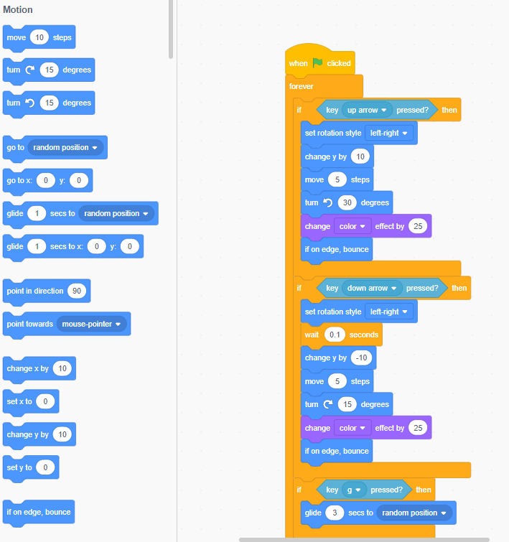

**Page 2 of Helicopter Animation Program**

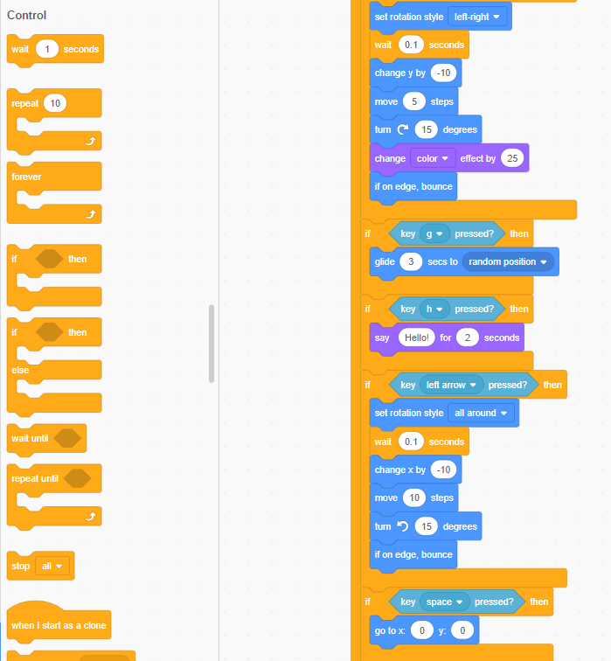

**Page 3 of Helicopter Animation Program**

